Installation Guide of USB Virtual Serial Port Driver

Updated on March 10, 2022

USB Driver Installer
USB-Driver-Install.exe

Installation instructions of USB driver
1. In general, Windows10 system has its own driver and does not need to install it again; Windows7 systems may need to install the driver.
2. Only NIIMBOT’s self-developed printer can use this driver installer.
3. Right-click “Computer” to find “Computer Management”-> “Device Manager”, which is shown below (the printer is identified as other devices), indicating that the USB virtual serial port driver is missing. This situation can only be solved by installing this USB driver.
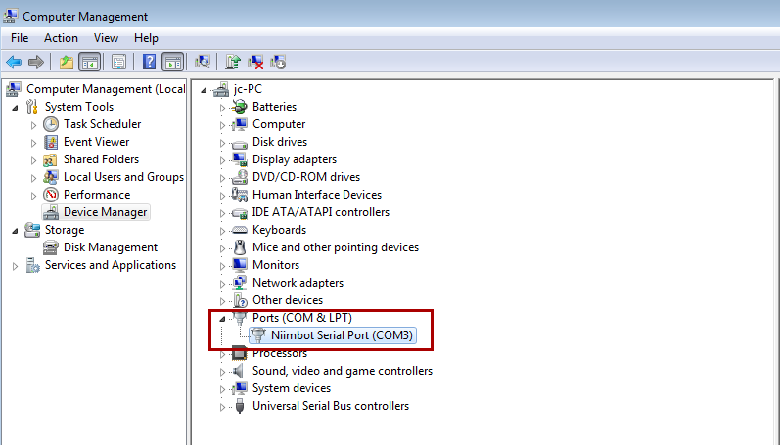

4. If you fail to install using the installer, you can install the driver manually in two ways.

Manual Installation

I. Manual installation mode 1 (script installation)

1. Double-click to run “usbinstall.bat”

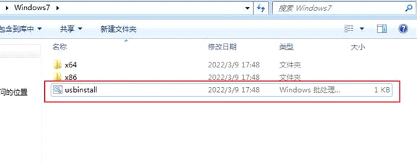

2. If the following window selection appears, tick Always trust, and select Install
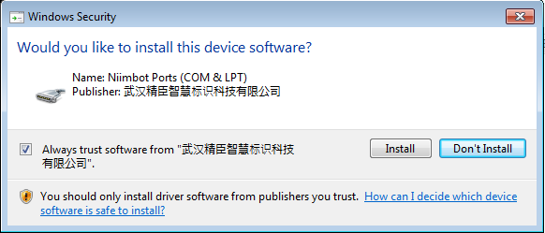

(Select “Always install this driver” if prompted as follows)

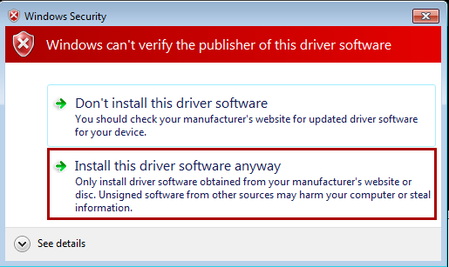

3. The successful installation is as below

II. Manual installation mode 2 (manually select Import driver)
1. Right-click “Computer” to find “Computer Management”-> “Device Manager” and find a device similar to the one shown below. Different printers may display different names.
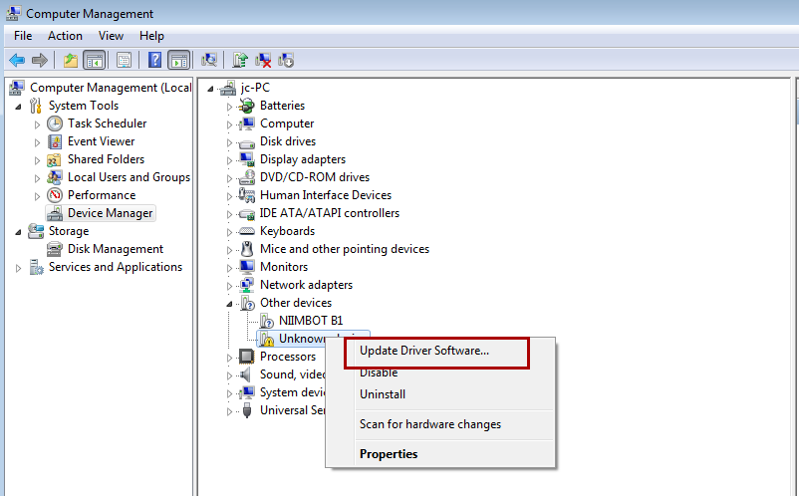

2. Right-click the corresponding device and select “Update the driver software” (it may take a while for this option to appear if the printer has just been connected)
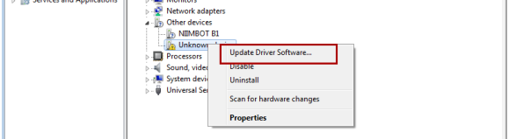

3. Select “Browse the computer for driver software”
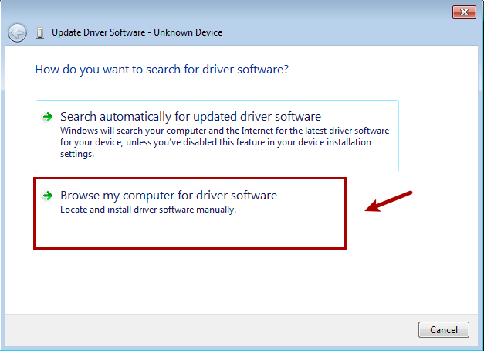

4. Select the folder where the driver needs to be imported, and select Next (x64 folder for 64-bit system, x86 folder for 32-bit system)

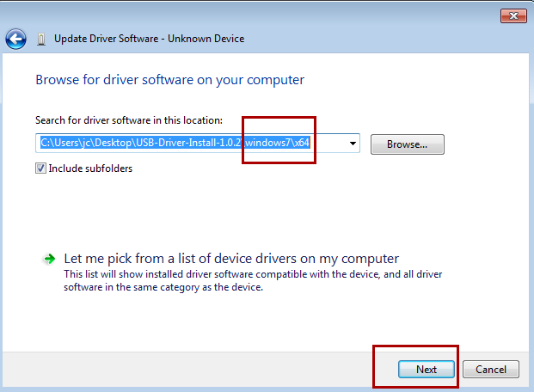

5. If the following Window selection appears, check Always trust, and select Install

(select “Always install this driver software” if the following window appears)

6. The successful installation is as below

